CONNECT WITH GOD: God knows you and wants you to know Him as God and Savior to receive from Him support, guidance, and peace in this life and assurance of an amazing new life after death. All are welcome here. Sunday services are that place where we come to gather and receive direction and grace. We never want to do things within our services just for the sake of doing them. We will do our best to align with Jesus’ invitation to worship in “spirit and in truth”.
CONNECT WITH FELLOW BELIEVERS: As part of our core identity, Redeemer by the Sea is a smaller gathering of people where we are thrilled to be able to get to know each other and care for each other. You will not be able to get “lost in the crowd” here. There are many opportunities to grow spiritually and serve others within the church and we are continually seeking ways to offer effective service to our community and world. If you’re ready to know more about these opportunities, contact Kay Boland, in the church office, 760-431-8990 x105, or by email at kay@redeemerbythesea.org.
April 21, 2024 ~ 8:30am
“Broken but bold”
WelcomE & announcements

OPENING HYMN “Sing Praise to God, the Highest Good” LSB 819
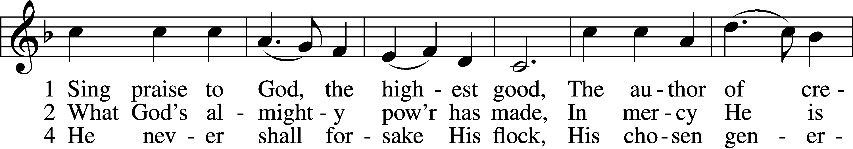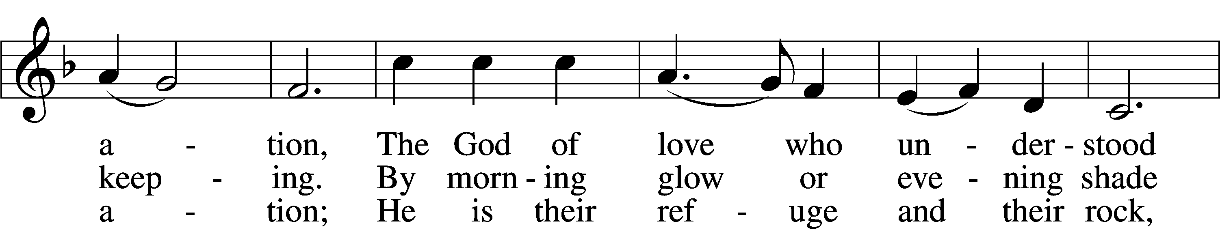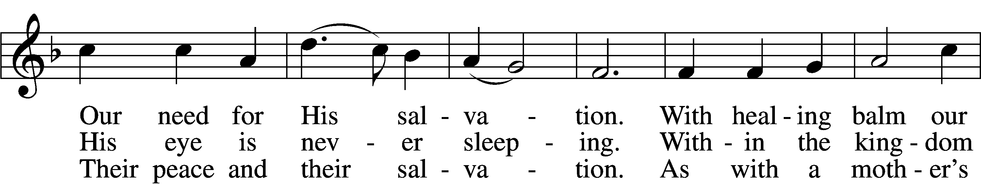
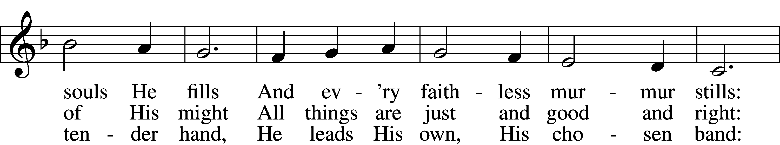
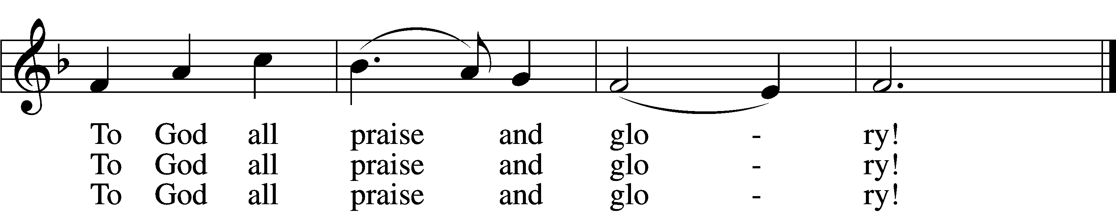
Text: Johann Jacob Schütz, 1640–90; (sts. 1–2): tr. Frances E. Cox, 1812–97, adapt.; (st. 4): tr. Catherine Winkworth, 1827–78, adapt. Tune: Melchior Vulpius, c. 1570–1615 Text and tune: Public domain

Invocation
Pastor: In the Name of the Father and of the X Son and of the Holy Spirit.
People: Amen.

Confession and Absolution
Pastor: Our help is in the name of the Lord,
People: who made heaven and earth.
Pastor: If You, O Lord, kept a record of sins, O Lord, who could stand?
People: But with You there is forgiveness; therefore You are feared.
Pastor: Since we are gathered to hear God’s Word, call upon Him in prayer and praise, and receive the body and blood of our Lord Jesus Christ in the fellowship of this altar, let us first consider our unworthiness and confess before God and one another that we have sinned in thought, word, and deed, and that we cannot free ourselves from our sinful condition.
(silence for further personal reflection and specific confession)
Pastor: Together as His people let us take refuge in the infinite mercy of God, our heavenly Father, seeking His grace for the sake of Christ, and saying: God, be merciful to me, a sinner.

Create in Me LSB 192
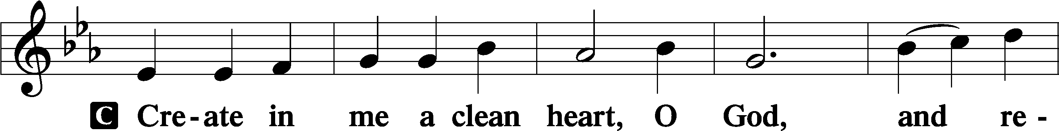
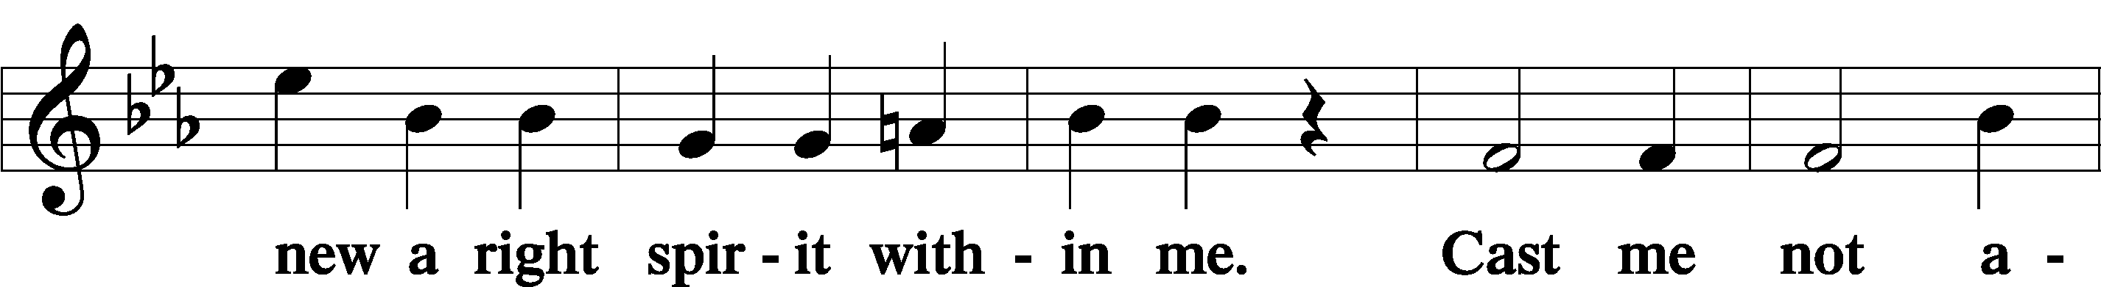
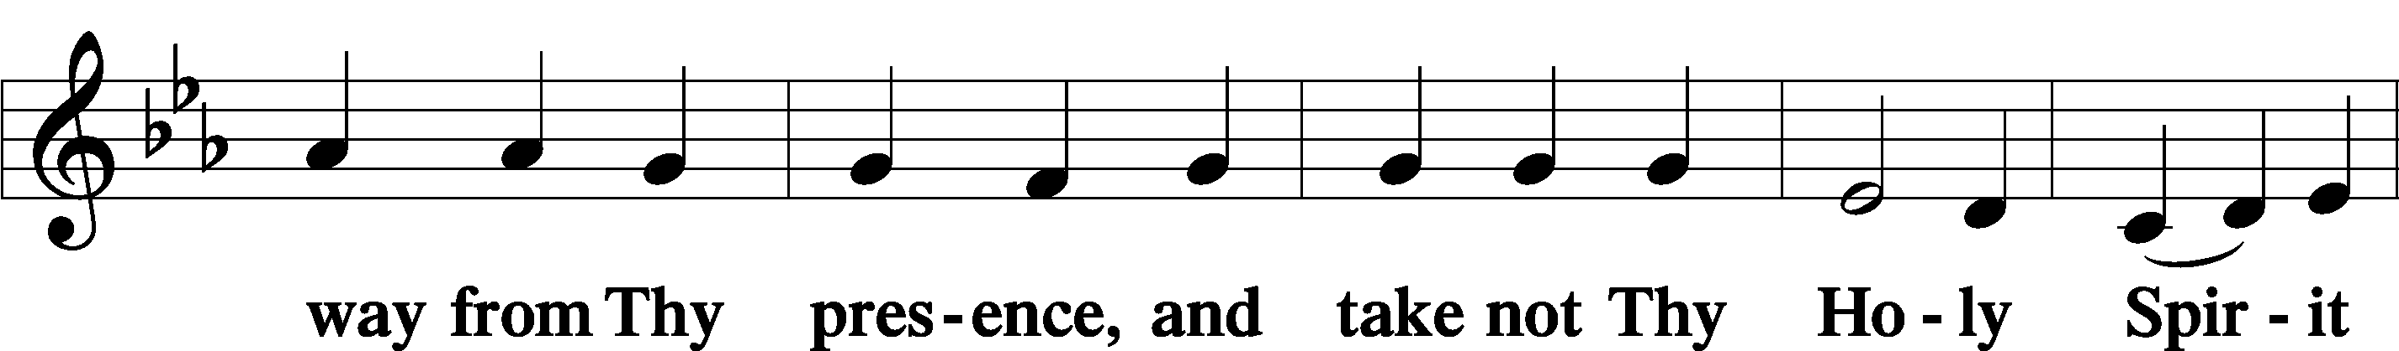
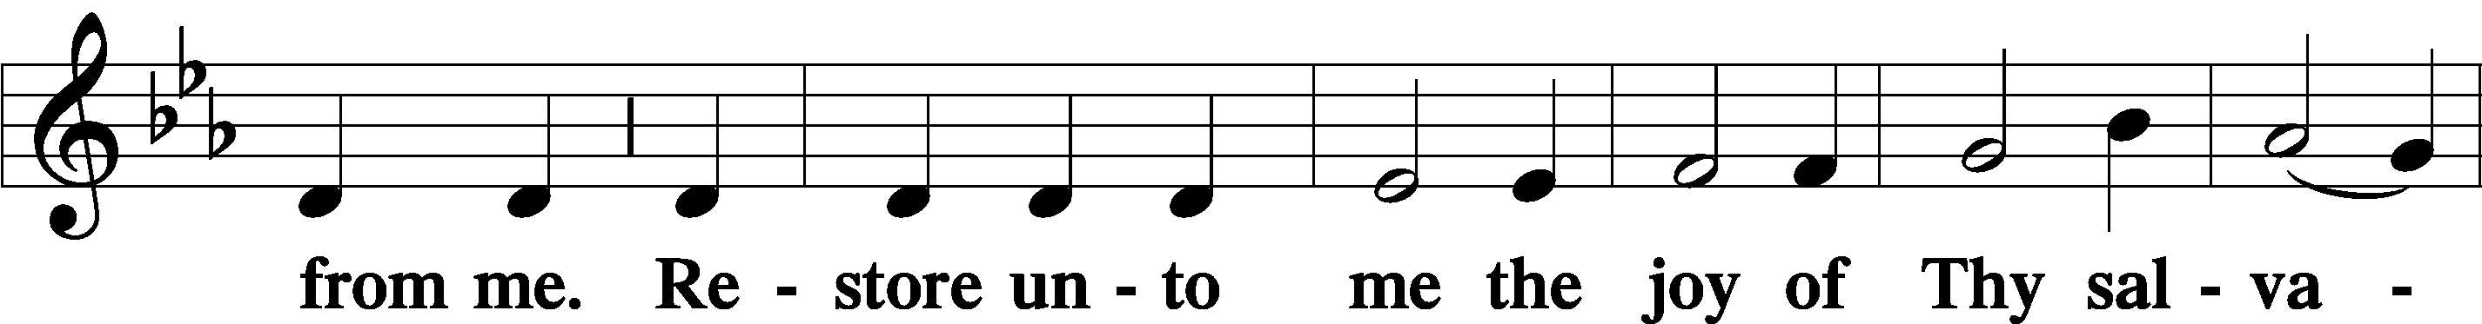
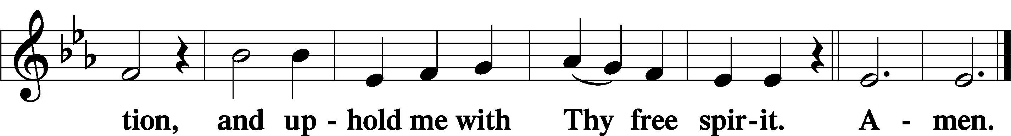
Pastor: For you who believe and trust that Jesus is God and Savior, through Him and for His sake God has heard our prayer. The Father sent His Son into our world, to die for us and to rise again that we may have new life. As a called and ordained servant of the word, and at the command of my Lord Jesus Christ, I announce the grace of God unto all you, your sins are forgiven, in the name of the Father and of the Son X and of the Holy Spirit.
People: Amen.

COLLECT OF THE DAY
ALL: Almighty God, merciful Father, since You have wakened from death the Shepherd of Your sheep, grant us Your Holy Spirit that when we hear the voice of our Shepherd we may know Him who calls us each by name and follow where He leads; through the same Jesus Christ, Your Son, our Lord, who lives and reigns with You and the Holy Spirit, one God, now and forever. Amen

sharing god’s peace
scripture reading 1 Samuel 17:23-27 (NLT)
Reader: This is the word of the Lord.
People: Thanks be to God.
scripture reading Ephesians 1:15-23 (NLT)
Reader: This is the word of the Lord.
People: Thanks be to God.
Holy Gospel Luke 12:4-9 (ESV)
Pastor: The Holy Gospel according to St. Luke, the 12th chapter:
People: Glory to you, O Lord.

(Following the reading)
Pastor: This is the Gospel of the Lord.
People: Praise to you, O Christ.

Alleluia and verse LSB 205
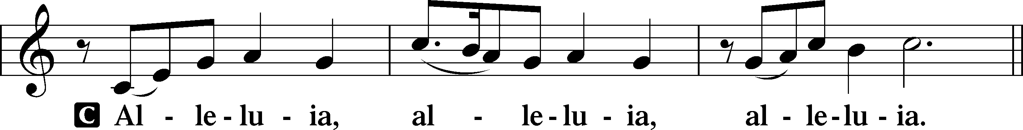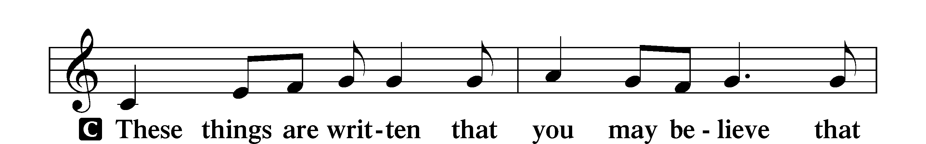
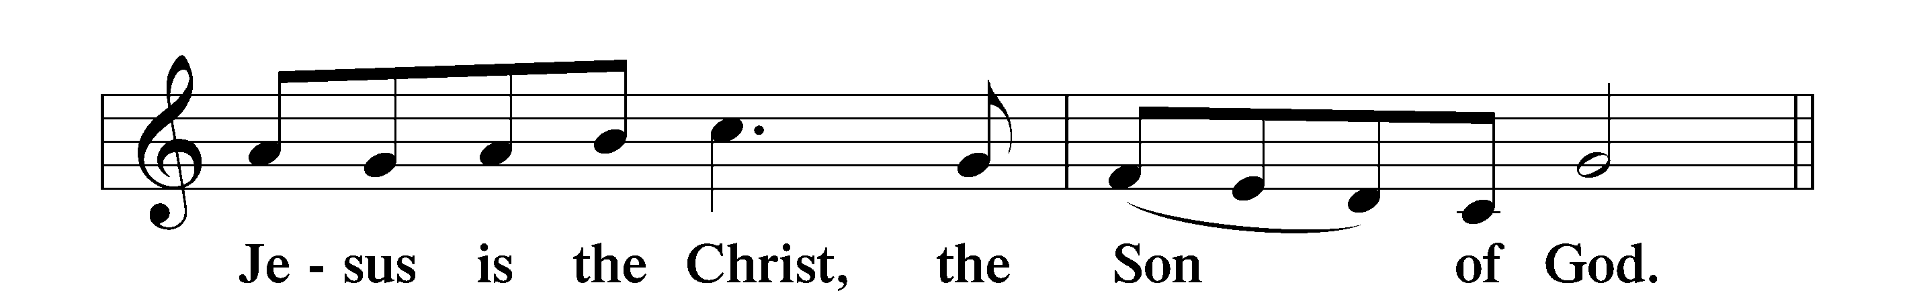
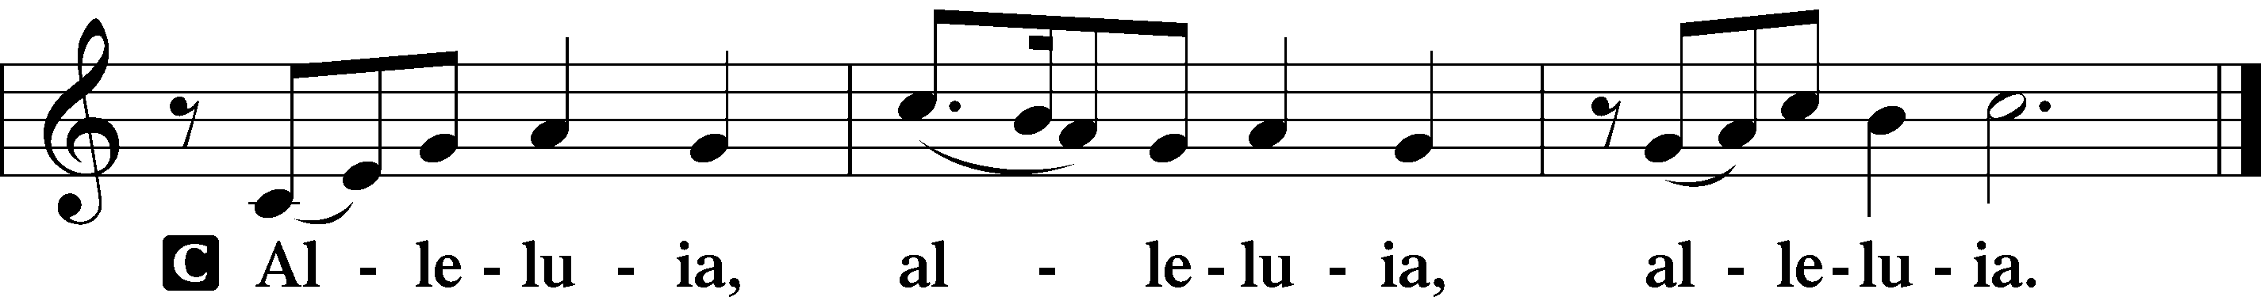

NICENE CREED
I believe in one God, the Father Almighty, maker of heaven and earth and of all things visible and invisible.
And in one Lord Jesus Christ the only-begotten Son of God, begotten of his Father before all worlds, God of God, Light of Light, very God of very God, begotten, not made, being of one substance with the Father, by whom all things were made; who for us men and for our salvation came down from heaven and was incarnate by the Holy Spirit of the virgin Mary and was made man; and was crucified also for us under Pontius Pilate. He suffered and was buried. And the third day he rose again according to the Scriptures and ascended into heaven and sits at the right hand of the Father. And he will come again with glory to judge both the living and the dead, whose kingdom will have no end.
And I believe in the Holy Spirit, the Lord and giver of life, who proceeds from the Father and the Son, who with the Father and the Son together is worshiped and glorified, who spoke by the prophets. And I believe in one holy Christian and apostolic Church, I acknowledge one Baptism for the remission of sins, and I look for the resurrection of the dead and the life of the world to come. Amen.

message Hymn “Christ the Eternal Lord" LSB 829
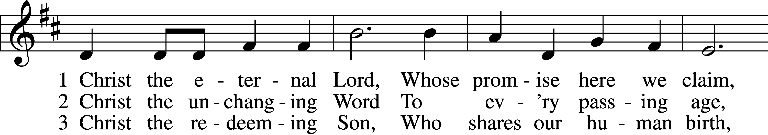
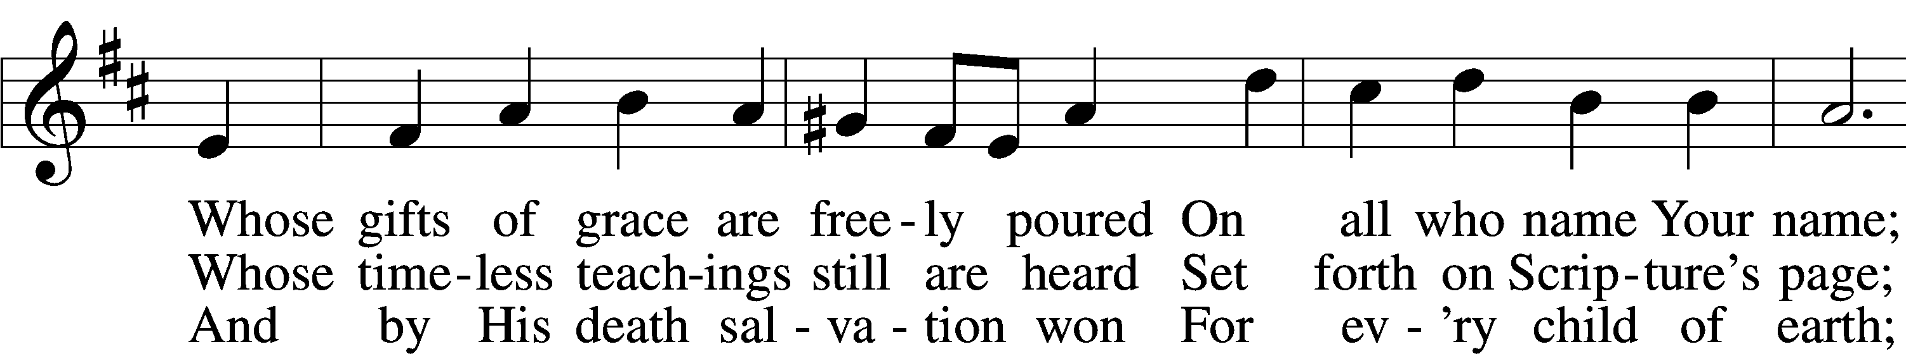
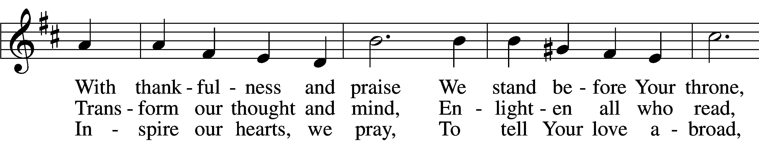
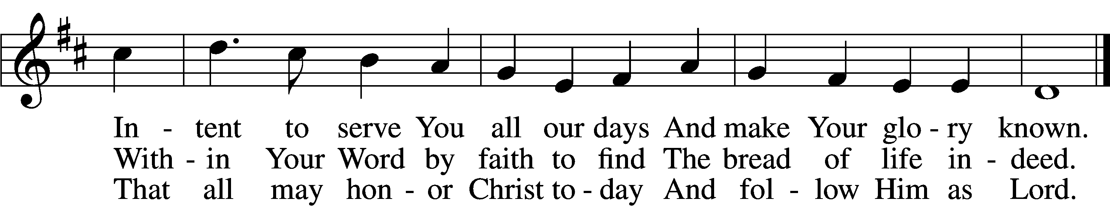
Text: Timothy Dudley-Smith, 1926 Tune: George J. Elvey, 1816–93 Text: © 1999 Hope Publishing Co. Used by permission: LSB Hymn License no. 110016216
Tune: Public domain

Message "Broken but Bold" Pastor D. R. Hilken

Prayers of the church
Pastor: (concluding each petition) Lord, in Your mercy,
People: hear our prayer.

LORD’S PRAYER

+ SERVICE OF THE SACRAMENT +

Words of Institution

Sharing God’s peace with one another
Pastor: The peace of the Lord be with you always.
People: And also with you.
Agnus Dei (You May Be Seated) LSB 210
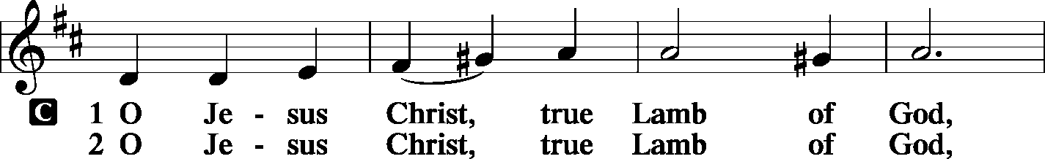
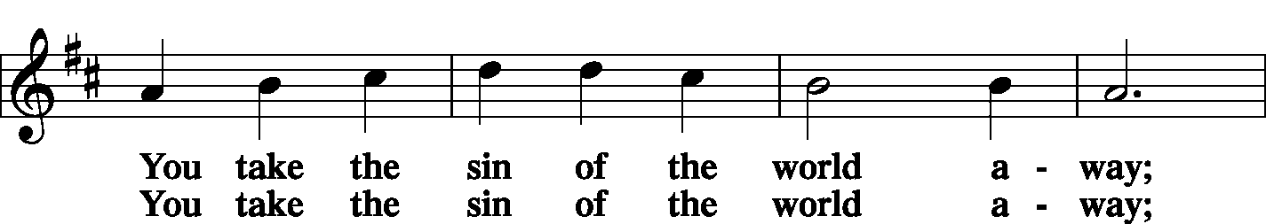
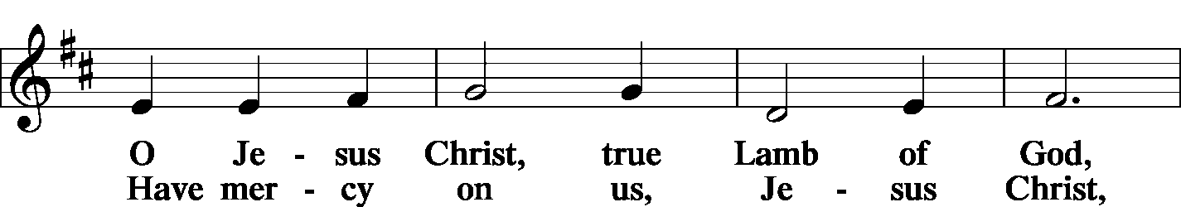
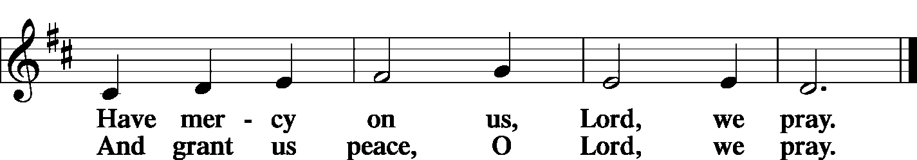

distribution

DISTRIBUTION HYMN “O Savior, Precious Savior” LSB 527
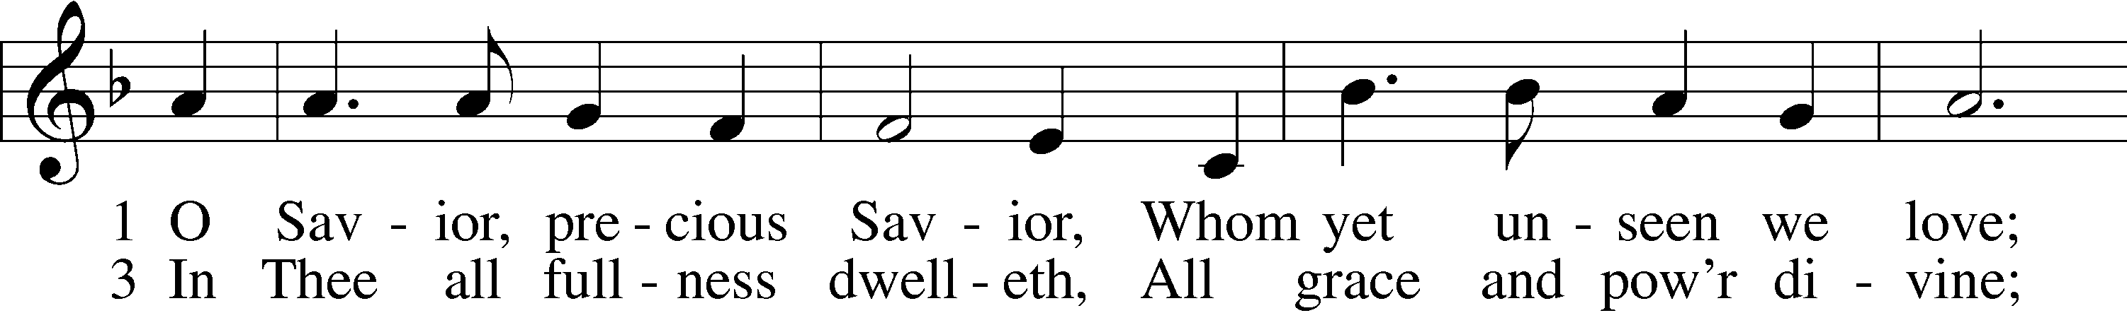
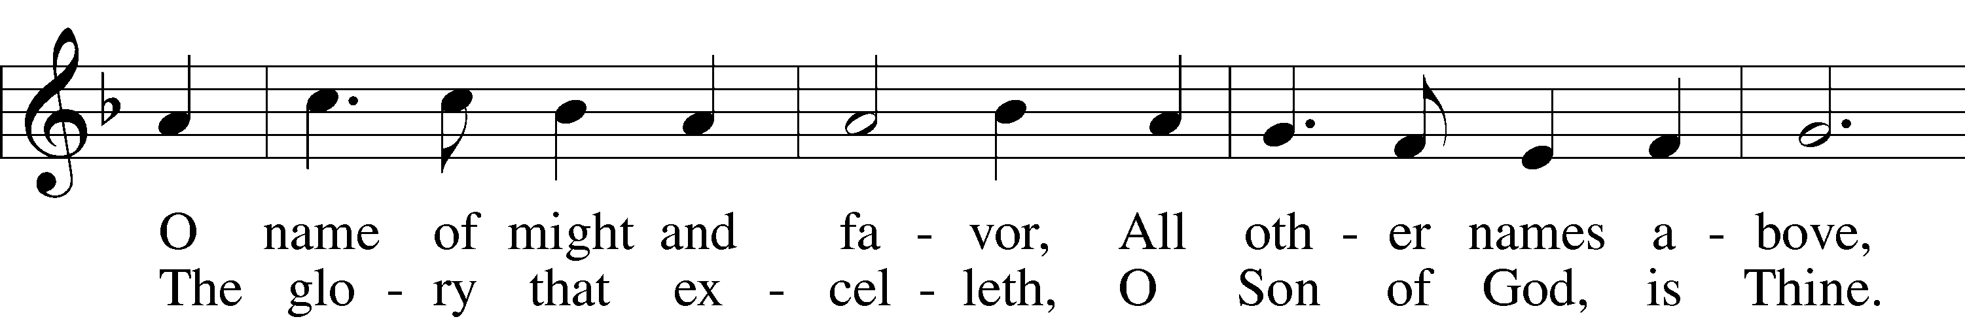
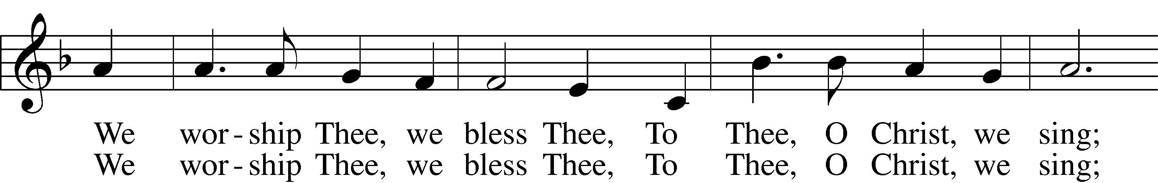
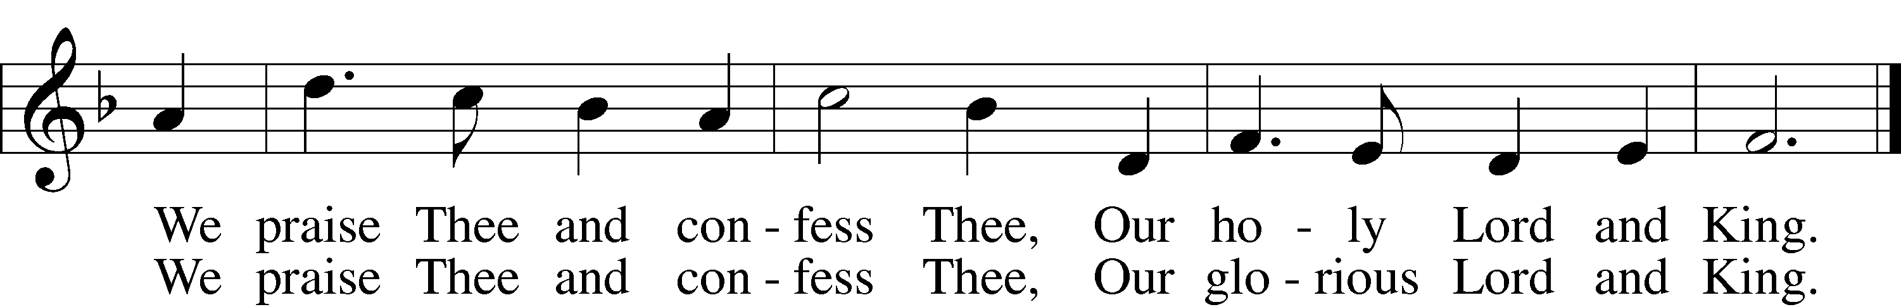
Text: Frances R. Havergal, 1836–79 Tune: Arthur H. Mann, 1850–1929 Text and tune: Public domain
Post Communion prayer
Pastor: We give thanks to you, almighty God, that you have refreshed us through this salutary gift, and we implore you that of your mercy you would strengthen us through the same in faith toward you and in fervent love toward one another; through Jesus Christ, your Son, our Lord, who lives and reigns with you and the Holy Spirit, one God, now and forever.
People: Amen.

Nunc Dimittis LSB 199
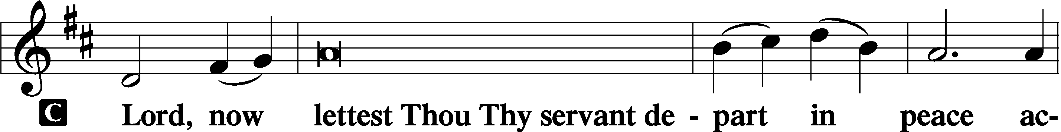
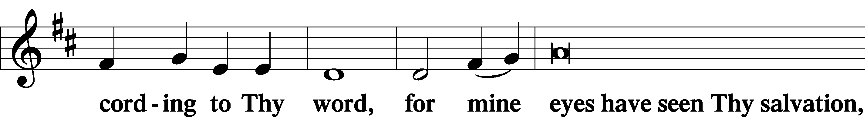
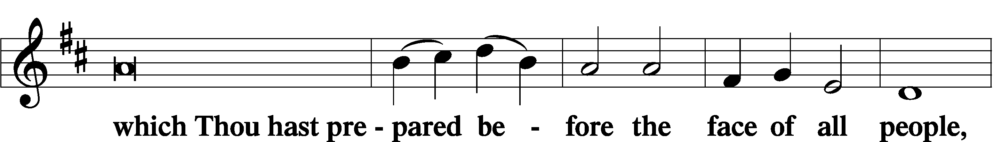
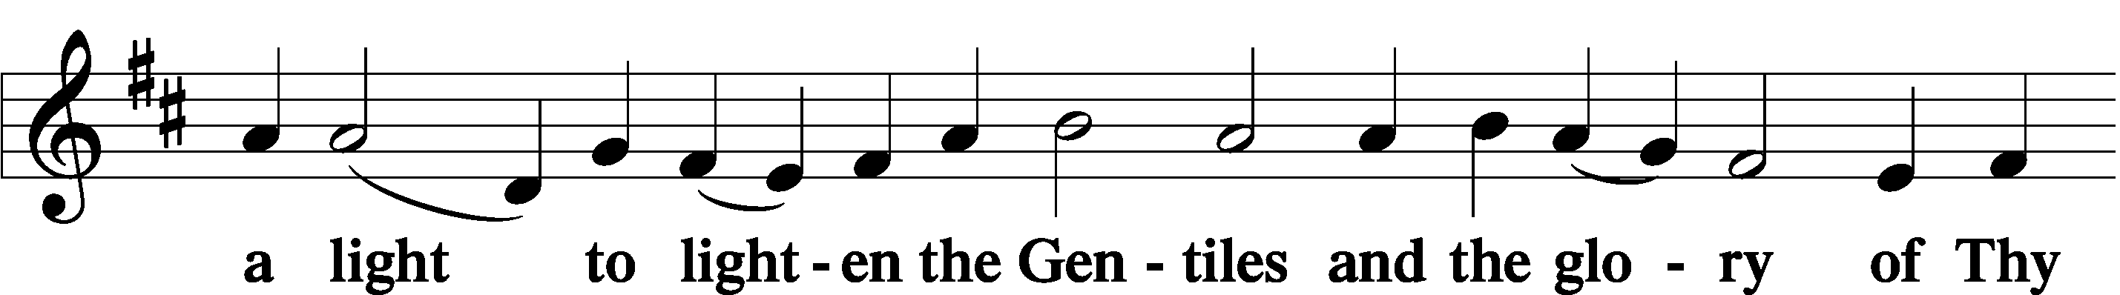
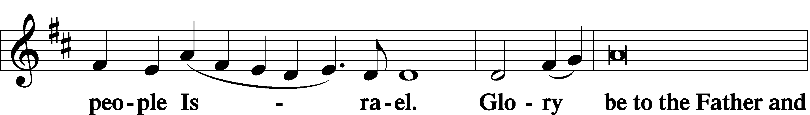
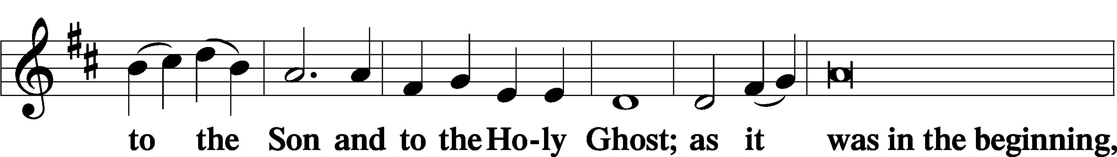
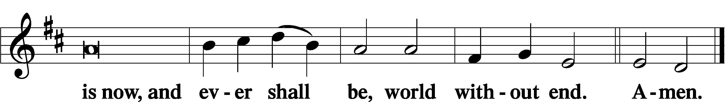

benediction
Pastor: The Lord bless you and keep you. The Lord make his face shine on you and be gracious to you. The Lord look upon you with favor and X give you peace.
People: Amen.

closing Hymn “Stand Up, Stand Up for Jesus" LSB 660
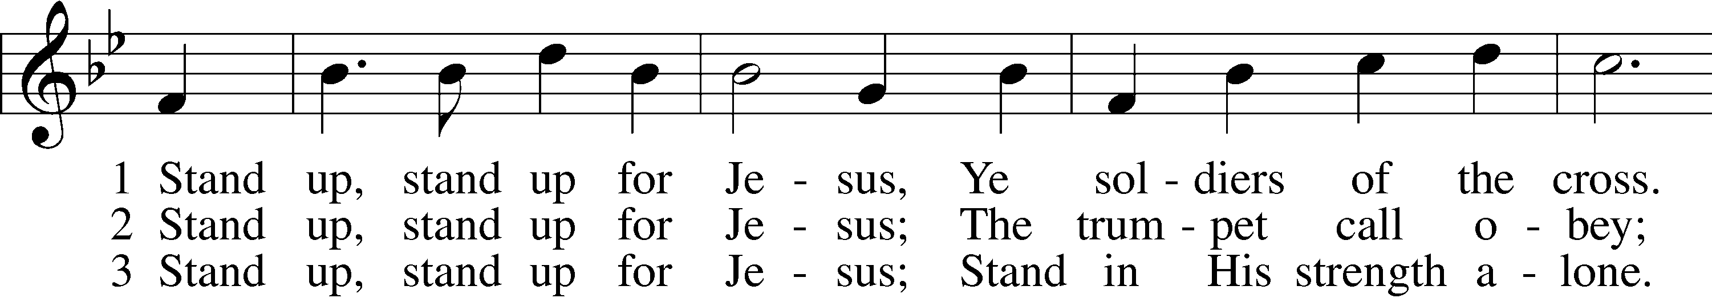
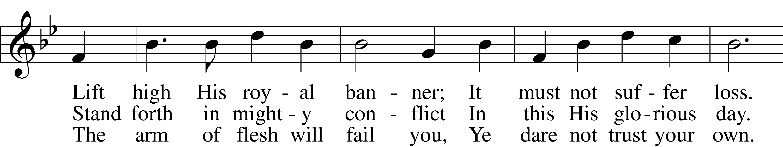
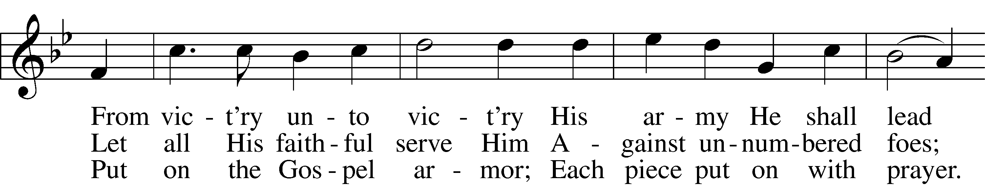
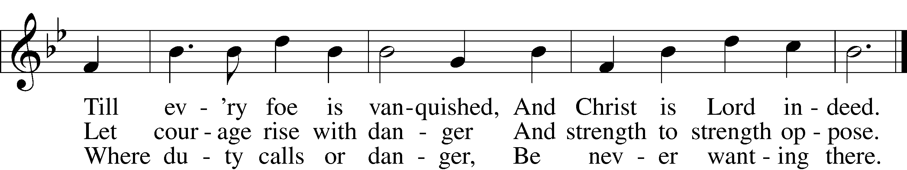
Text: George Duffield, Jr., 1818–88, alt. Tune: George J. Webb, 1803–87 Text and tune: Public domain

Sending
Pastor: Go in peace and serve the Lord.
People: Thanks be to God!

Postlude “Fanfare on Austrian Hymn (Glorious Things of Thee Are Spoken)” by Gordon Young

Acknowledgments: Unless otherwise indicated, all scripture quotations are from ESV. UBP. ARR. Created by Lutheran Service Builder © 2006 CPH
WORSHIP | GROW | SERVE
OFFERINGS: Visitors: please consider yourselves our guests and do not feel obligated to participate in the offering. In faithful obedience and joyful response to God’s grace in our lives, we humbly and gratefully bring our tithes (a regular first portion percentage of our income) and offerings (gifts over and above our tithes for other kingdom work). You may deposit your envelope, check, or cash in the box next to the exit; give online with your phone using the QR code at right or text "GIVE' to 442-222-2448. All of these options are on our website: www.redeemerbythesea.org/donate/.
CHILDCARE NOW AVAILABLE BOTH SERVICES ON SUNDAYS: Sofia would love to care for your children while you attend worship!
BIBLE STUDY
Pastor D. will be leading a Bible study utilizing season 4 of “The Chosen.”
This study will be offered twice a week.
Tuesdays at 4:30pm or Wednesdays at 9:15am.
All are welcome to attend.
MORE THAN MONEY MATTERS workshop presented by Jeff Crane and Tom Wills from Thrivent. We will explore how to get to and through retirement as well as ways to leave a lasting legacy in tax-wise ways! Jeff and Tom love serving North County, with offices in both Vista and Carlsbad. They specialize in retirement and investment planning, tax diversification, and investing with purpose, helping people support their families, church, or community. Please let us know you plan to join us in person at one or both of these presentations by submitting your RSVP online.
Sun. April 21st at 11:45am in the Fellowship Hall. Lunch and beverages will be provided.
Wed. May 15th at 6:00pm in the Fellowship Hall.
UPDATED: MEN’S FELLOWSHIP BREAKFAST: The next date is Sat. May 4th at 9am in the Fellowship Hall at Redeemer by the Sea. This is always a great day to gather with friends and meet someone new. Choose your burrito from Valerie’s Tacos when you register online.

RBTS KINDERGARTEN SING: At 10:15am on Tues. May 14th following the 9:30am LWM business meeting, our own RBTS Kindergarten will sing, then we will all decorate cookies together. This is always a great time reflecting that we are all called children of God! Please join us in the Fellowship Hall.
SCUBA VBS: Register your child (ages 4-9) for SCUBA VBS at Redeemer by the Sea June 24-28th from 9am to noon. Kids will dive into friendship with God and discover how to shine Jesus’ love and hope in everyday life. Activities include catchy songs, teamwork building games, yummy treats, Bible Adventures and Sciency-Fun Gizmos. TODAY is the last day to take advantage of Early Bird Registration for $140. After today the price goes up to $150. All registrations are non-refundable. Space is limited, so register early on our website.
VBS SERVE TEAM NEEDED: VBS cannot happen without your help! We need both Crew Leaders (over 18 years of age) and Assistant Crew Leaders (ages 6th grade and up). Please register online to join the team and then reserve these dates on your calendar June 24-28th from 8:30am to 12:30pm. This is always a fun week sharing our faith in Jesus to kiddos in our area!

UPCOMING EVENTS:
www.RedeemerbytheSea.org
APR 21ST 11:45am More Than Money Matters
MAY 4TH 9:00am Men’s Fellowship Breakfast
MAY 14TH 9:30am LWM Business Meeting
10:15am RBTS Kindergarten Sing & Cookie Decorating
MAY 15TH 6:00pm More Than Money Matters
JUNE 12TH 5:30pm VBS Staff Training
JUNE 24-28TH 9am-noon SCUBA VBS
This week’s altar flowers donated in celebration of Heidi Busch’s birthday!

